JS ADVANCED MATERIALS LABORATORY

Experiment: ATOMIC FORCE AND SCANNING TUNNELING MICROSCOPY

Summary: In the following experiment you will use Atomic Force Microscopy (AFM) and Scanning Tunneling Microscopy (STM) to investigate the surfaces of some common advanced materials. You will be preparing your own nano-scale structures and characterizing them using the high spatial resolution of these techniques.

Introduction
The techniques of STM and AFM fall under the category of Scanning Probe Microscopy; they were developed in 1980’s and are widely used today in practically every university or research institution. Both microscopes are non-optical and use a pointed probe that is sharp to within a few atoms to gather information about a surface. These methods have very different modes of operation.

The STM uses a metal stylus positioned close to the surface. A potential difference between the tip and sample leads to quantum mechanical tunneling current (as a current must be maintained, the technique can only be used on metallic or semiconducting substrates). The probability that an electron will tunnel across the potential energy barrier is proportional to e^{-kd}, where k is a decay constant and d the tip to sample separation. The tunneling current is then proportional to e^{-2kd} – explain this.
The decay constant, k, is determined by fundamental constants including Plank’s constant and the mass of the electron. Using a typical energy barrier height we can show that the tunneling current increases or decreases by an order of magnitude for each angstrom change in the barrier width. This is important for two reasons. Firstly, it means that the vast majority of the tunneling current is sourced from the single atom at the end of the tip – this allows for very high spatial resolution. Secondly, it means that the technique is capable of detecting the slightest variations in the smoothness of a surface. True atomic resolution is possible because of the exponential dependence of the current on height. You should appreciate that an STM does not reveal entire atoms but rather maps the local density of electronic states as the tip scans the surface.

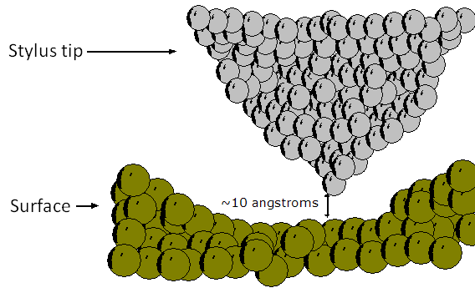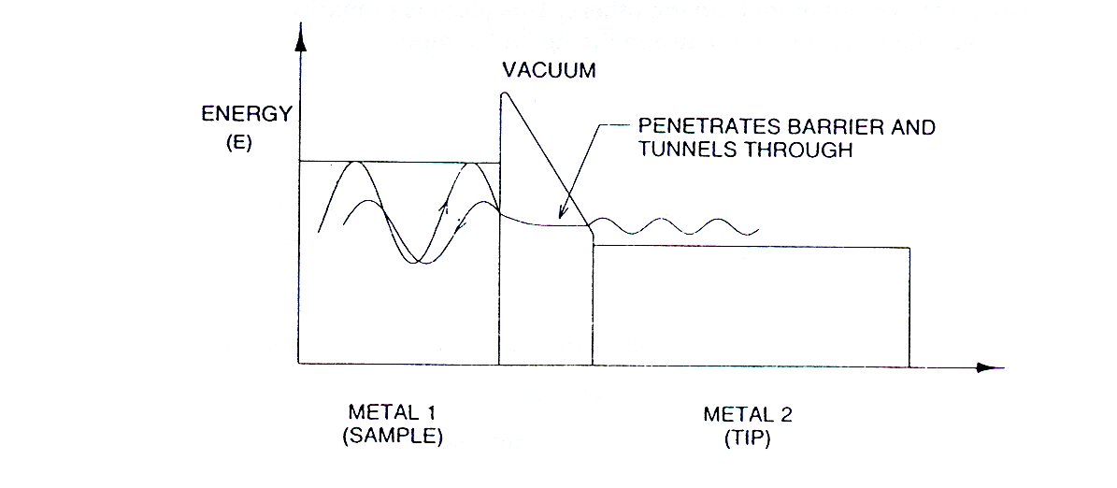
Figure 1: STM tip interaction with surface

Obviously, the instrument must be able to precisely control the height of the tip above the surface. The tip is positioned by piezoelectric materials; these expand or contract in a proportionate manner in response to an applied electric field. In one mode of operation, a constant height is maintained over the surface with the changes in current fed directly to the screen; this gives a current map of the surface. In the other mode, as in this experiment, a constant current is used where a negative feedback loop controls the tip height; the tip is advanced towards the surface if a fall in current is detected or withdrawn if the current rises. The fixed constant current is referred to as the “setpoint”. Recording the position of the tip gives the surface topography. The setup is illustrated in Figure 2.
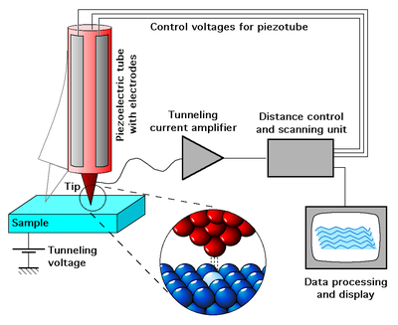
Figure 2: STM electronics setup (from Wikipedia)

For AFM, the operating principle is radically different. The probe in this case (generally made from silicon) is at the end of a relatively long cantilever that is attached to a chip (see Figure 3). The “tip” can refer to the atomically-fine pointed probe at the end of the cantilever or the entire assembly of tip/cantivlever/chip as shown in Figure 3 – what’s intended depends on the context.
The short range repulsion between the tip and sample causes a deflection of the cantilever. The deflection of the cantilever as it passes over the sample’s features is monitored by a laser/photodiode pair. This particular machine uses so-called “constant force”, or contact mode. The deflection of the cantilever follows Hooke’s law where the force applied to bend the cantilever (from the tip-surface interaction) is proportional to the cantilever displacement. The instrument brings the tip close to the surface and fixes this force, or setpoint, by multiplying the measured displacement by the known spring constant of the cantilever.

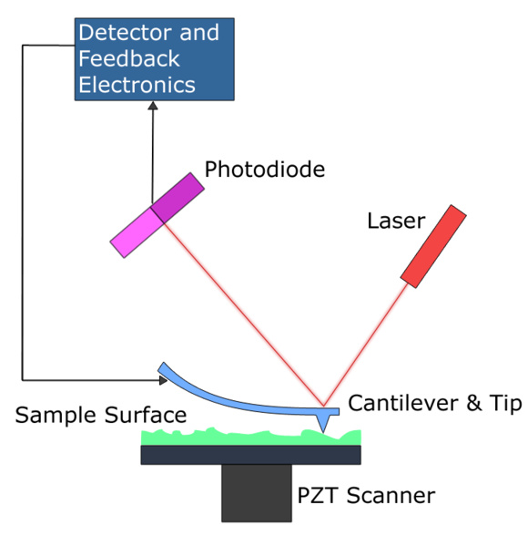
Figure 3: AFM tip mount and cantilever, and schematic of operation.
While contact mode AFM ultimately provides the best resolution, there are some drawbacks; namely, damage to tip and sample can occur if the force setpoint is too high, or sudden changes in topography occur too quickly for the tip to react. To avoid these issues a new mode was developed known as tapping mode. Here the cantilever is oscillated at it’s resonant frequency (50-500 kHz) by a piezoelectric motor. The tip is brought into contact with the sample such that the maximum amplitude of oscillation is reduced. In this way the tip may track the surface while applying much lower forces compared with contact mode AFM. For more information, see “Atomic Force Microscopy” by Eaton & West (Ham. Library, 502.8 R01).

Equipment Operation
The apparatus consists of separate STM and AFM scan heads and the “Nanosurf Easyscan 2 controller” that is operated using PC software. The scan heads are extremely delicate and should be handled with great care. Each head sits on its own stage. As vibration isolation is important, the apparatus should only be used on the optic bench. You must never touch the probe ends as this will render them useless and/or damage the instrument. For initial setup of the apparatus you should consult your demonstrator. You should only exchange the scan heads when the controller is powered off. Instrument calibration and training is necessary. As with any sophisticated instrument some preparatory measurements are necessary before obtaining specific results with the instrument. Test samples allow for verification of performance, accuracy, reproducibility as well as learning about the specifics of the tip and/or cantilever that is used.

AFM
You will use AFM to image two substrates as part of the calibration and training on the instrument. These will be from the extended AFM sample kit provided and will be:
- Microstructure/calibration grid
- Chip structure in silicon

You will then be asked to perform two of the following four experiments. The specific two experiments will be selected for you on the day by your demonstrator. If time allows you may return, after completion of the STM experiment to the remaining two experiments. These four AFM experiments are:
- CD stamper
- Glass beads/virus
- Nanotubes
- Gold clusters
For each experiment there are detailed results that can be obtained directly from either the AFM images or from further analysis or consideration of the AFM measurements.

The AFM head requires great care when handling. You should never touch the tip’s mounting or attempt to change the tip yourself…they will break and they are very expensive. This particular scan head uses contact mode whereby a constant repulsive force is maintained between the tip and the surface. The surface is mapped by measuring the deflection of the cantilever as the tip passes over the surface. Therefore, only relatively flat samples can be measured with this instrument (max “z-height” is 14µm).

Sample Loading:
You should consult your demonstrator when first loading samples – you need to ensure there is sufficient clearance between the cantilever and the sample stage before loading your sample. The sample should be placed on the post-it piece on top of the holding disc. This disc should be grounded and connected to earth with the black lead (consult the demonstrator).
Then, manually adjust the screw legs on the AFM head to bring the tip to within a few millimeters of the surface. Again, in the software use the “ADVANCE” button. The video camera gives top and side views (the side view works best for approaching). You can adjust the illumination, contrast and brightness to suit. Bring the tip close enough to the sample such that the cantilever is about twice its own length away from its shadow.

Imaging:
Start with the calibration grid, this has a grid of square holes etched into it.

- Set the force to 10nN, this is the constant repulsive force that is maintained between the tip and the sample. Higher values mean the tip will be closer to the surface and will be more at risk of crashing.
- Set the scan area to about 50 µm at first to get an overview of the surface.
- Then use the “APPROACH” button to do the automatic approach.
- If the tip is continually losing contact with the surface, try a slightly higher force value of say 15nN.

Again, you should be able to adjust to the scan parameters such as the points per line and time per line to optimize the images. The lateral dimensions (i.e. in the XY plane) are not a true reflection of the size of the feature. This is because the tip is not like a needle sharp to a single atom. Typically the tips have a “v-shape” profile and will roll over sharp surface features to make the features seem wider than they actually are. The z-height taken from an image is much more reliable as this relies only on the interaction between the very end of the tip and the surface. This is illustrated in Figure 4 below.
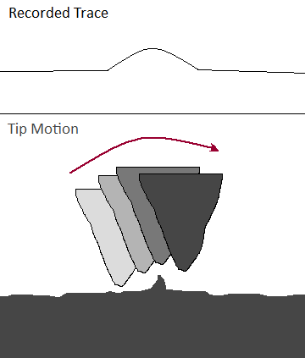
Figure 4: Distorted spatial features in AFM

Aims of each experiment:

Experiment 1: Microstructure/calibration grid
You should aim to:
- Measure the depth of the holes in the calibration grid.
Take a suitable image and take a line scan of the acquired data. How does this measurement depend upon the size of tip? What are the limitations? Is there any dependence upon scan direction?

Experiment 2: Chip structure in silicon
You should aim to:
- Optimize the gain settings as instructed in the extended manual. See what the effect of higher than optimal and lower than optimal gain is on the image acquisition. Acquire images and topographic line scans for these conditions.
- Measure the height of the features seen in the chip structure in silicon

Experiment A:
You should aim to:
- Measure the height of the master bits in the CD stamper and estimate the width of each bit. What is the areal density of the bits? What limitation does this put on the storage capacity, i.e. the areal memory density?

Experiment B:
You should aim to:
- Measure the radius of the tip (see manual for specific instructions). How does your measured radius compare with the manufactures specifications? Can you account for the difference? Measure the radius of an old tip and compare it to a newer one. Is the difference reflected in the image obtained from each?

Experiment C:
You should aim to:
- Measure the radius of the tip (see manual for specific instructions). How does your measured radius compare with the manufactures specifications? Can you account for the difference?
- Measure the radius of an old tip and compare it to a newer one. Is the difference reflected in the image obtained from each?

Experiment D:
You should aim to:
- Obtain a roughness value of the sample at different scan sizes centered on the same area scanned at the same rate. How does the roughness change? Can you account for this change?
- Obtain a roughness value of the same scan area scanned at different rates. How does the roughness change? Can you account for this change?
- Guidelines on how to calculate roughness values are given on pages 45 and 46 of the manual. Follow these guidelines carefully.

STM
Experiment 3: This part of the laboratory experiment introduces scanning tunneling microscopy (STM) technique, used to obtain real space atomic resolution images of conductive surfaces. The tunneling spectroscopy mode of STM is employed to examine local density of states (LDOS) of surfaces.

Aim: Attain STM images of ordered surfaces and calculate atomic spacing.

IMPORTANT: Read carefully the instructions in the nanosurf lab manual [pages 25-48] and follow them closely. They will provide you with information about (i) preparation of the experiment, (ii) the procedure for attaining the STM images, (iii) the procedure for closing the experiment, and (v) on how to process/analyze the STM images

Tip preparation:
The tips should only be changed with the controller powered off. The STM tips are manually cleaved from a 0.25mm platinum-iridium wire. The idea is that cutting the wire whilst applying a tensile stress along the direction of the cut will draw the wire to an atomically fine point or points. Only handle with the wire with the supplied cutters and non-magnetic tweezers, if these tools are dirty clean them with ethanol.
Cut approx 5mm of wire, holding one end firmly in the pliers.
Hold the cutters at an oblique angle, a millimeter or two from the other end of the wire.
Bite into the wire with the cutters but do not cut through. Pull as shown in Figure 5 to tear off the wire and make the tip. Do not touch the sheared end of the tip off anything!
Hold the tip with the fine pointed tweezers. Align the tip wire parallel the groove and place it under the tip clamp. Move the wire sideways as shown to place the tip in the groove. If you are not sure about this step, ask the demonstrator.

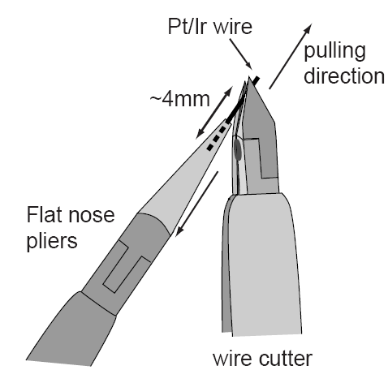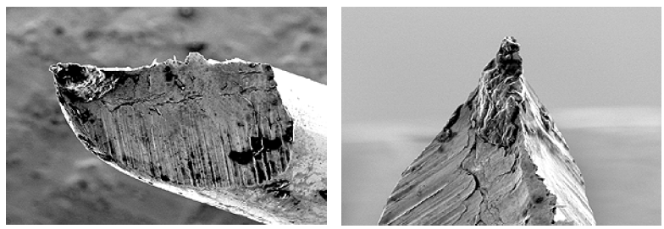
Figure 5 : Cutting the STM tip and SEM images of tips

Sample Loading:
Samples are stuck onto the holding pucks with silver paint. Samples should never be touched once prepared. For STM, the puck is then magnetically attached to the metal cylinder; this cylinder should only be held by the plastic end cap. Put the sample holder down onto the gold guide-bars and then release gently into the slot. Gently move the sample to within about 3mm of the tip. Cover the scan head with the cap. Use the magnifier to check you can see a mirror image of the tip in the sample surface.
In the software, you can then use the fine manual approach to bring the tip close enough to the sample so that the gap is barely visible – use single mouse clicks on the “ADVANCE” button or hold down to move the stage continuously.

Imaging:
The HOPG sample should be investigated first.
Enter the appropriate settings for the “Z-CONTROLLER” and “IMAGING”.
- Set the scan area to about 500 nm with 256 points per line. Initially, use around 0.5 seconds per line. For small box sizes (around 4nm) you can achieve atomic resolution on HOPG using 0.06 seconds per line. Short times will lessen the effects of thermal fluctuations.
- For HOPG, the tip voltage should be 50mV. For the transition metal dichalocgenide samples you may need to try higher values of around 0.5 V.
- The current setpoint should always be 1.0 nA. Do not change this setting.
- Then press “APPROACH” and wait for the “Approach Done” window to pop up. Check that the probe status light on the controller unit is green. If it is red, the tip has crashed into the sample and may have to be replaced. If it is still amber there may have been what’s called a false engage – contact has not been made maybe because of a temporary current blip that fools the controller, try withdrawing and engaging again. If this doesn’t work, the sample may be a bit too far from the tip so withdraw and manually advance the tip with one mouse click, then try the approach again.

When the approach is complete, you can try altering the number of points per scan, time per line, and scan area. Here are a few notes that will help you obtain better images:
- You may find that the line trace for the topography is at an angle. You should use a still image and the angle tool to correct this. Ideally, the place of the measurement and the sample surface would lie in the XY plane. The problem is illustrated below.

In the “Topography” window, measure the angle of the trace relative the x-axis with the angle tool. Then compensate by entering this value in the X-slope box (use negative value to rotate counterclockwise). To get the y-axis angle, rotate the scan direction by 90° and repeat.
- Thermal drift will cause stretching or blurring of the image along a particular direction. Temperature shifts of as little as 0.1°C can cause components like the steel sample holder to flex by a few nanometers. You will notice this effect if you start seeing atoms! The effect is quite noticeable for the HOPG surface at scan sizes of around 4nm. The drift should decrease over the time period that the cap is placed over the scan head, you may need to allow up to 20 minutes to get a good image. The idea to correct for drift is to get the tip’s scan direction along the direction of drift. You should try to rotate the image to attempt this. This can be tricky.
- It can be useful to display the tip current. Do this by creating a new chart and then selecting the tip current. This map would ideally be flat if the instrument were able to maintain a perfect constant tunneling current between the tip and the sample. This would happen for a perfectly flat sample. For typical samples, the system detects a change in tunneling current due to changes in surface height and then adjusts the probe height to compensate and maintain the setpoint current. The tip current shows these minute current changes and can give a better idea of the surface topography than the z-height.
- A blank topographic or current image means no data is coming through and the tip has lost contact with the surface (also, there will be an amber light for the STM status). Withdraw and re-engage or move to a new area.

You should find a flat area and zoom in to a box between 3 and 10 nanometers across. Use the “PHOTO” button to capture an image at the end of the current scan, if not scanning then the current window is captured. You can then save the image in your folder on the D:\ drive in the default format (.nid extension) or export as a JPEG file for your report. You can apply the analysis tools to any saved data file. The length, distance and angle tools are the most commonly used.

Experiment E:
- You should take and export appropriate images to illustrate the effect of slope correction and to illustrate the change in image quality with scan time.
- If you get some really good scans you can aim for atomic resolution in graphite. Describe the pattern you see. You can estimate the carbon-carbon bond length in the plane of a graphene sheet and measure the C-C bond angle. Compare the values obtained with the literature values.

Experiment F:
- Image a bulk transition metal dichalocgenide (TMD) single crystal of either TaSe₂ [[tunnelling parameters of 2-3 nA and 10-20 mV gap voltage] or WSe₂ [Typical tunneling parameters are 1.6nA tunneling current and 0.35V gap voltage].
- Obtain a lattice constant for the TMD and compare with literature values account for any discrepencies.

Questions that should be addressed in your report :
These are in addition to the specific instructions and questions above
- Because these experiments were conducted in air, air, adsorbed water, solvents, and gases are undoubtedly on the surface. How do these molecules affect the tunneling process and how might the tip perturb their distribution? Contaminants on the tip are also likely problems. Explain how this would affect the noise on your STM experiment
- What would the order of magnitude of the electron’s energy in eV have to be for your electrons to have a wavelength comparable to the size of the atomic spacing in graphite?
- Sketch the tunneling phenomena between a metallic STM tip and a metallic sample surface at (a) no bias voltage, (b) positive voltage, and (c) negative voltage.
- Sketch the electronic structures and I-V curves of tunneling spectroscopy of the four systems; metallic, semi-metallic, semiconductive, and non-conductive.
- Review current research into TMD’s in your report and discuss one potential application. Discuss the advantages of using TMD’s for this application.

